Deregistration form 2023-2024
Please send to secretaris@donitas.nl
To make sure the withdrawal symptoms of leaving Donitas aren't too great, there's a former Donitas Association called Alumnitas. Through this association you remain involved in the association and with the friends you made during your Donita period. The Alumnicie organizes a number of activities every year where you are always welcome as an Alumnitater. In addition, Donitas will keep you informed about everything that is going on within the association via the 4 Alumniteurtjes that are sent throughout the year. To make sure you stay updated about Donitas, you can become a member of the G.S.V.V. Donitas Alumni Facebook group! When you want to stay up to date, please send a membership request to become a part of this group. Being an Alumni is free of charge. Note! The Alumni updates are (unfortunately) only in Dutch.
Donitas can be very active thanks to the financial support of many former Donitas members. If you financially support Donitas you will receive a hardcopy Alumnizine next to the four digital updates each year. Note! Once again, this is in Dutch. In case you want to financially support Donitas, you can fill this in below.
Would you like to financially support Donitas?
☐ No, thanks* ☐ €20,- per year** ☐ €30,- per year** ☐ €…………,- per year**
(Minimum of €20,-)
with / without exception of the first year.
☐ I would like not to stay updated
* When you become an Alumni for free, relevant personal data will be saved (former student number, first name, last name, sex, date of birth, email address, phone number, photo).
** When you become an Alumni and financially support Donitas, relevant personal data will be saved (former student number, first name, prefix, last name, sex, date of birth, email address, phone number, photo, address, postal code, city, IBAN number).
Personal details
I would like to deregistrate as a member of G.S.V.V. Donitas.
First name: …………………………………………… Reason deregistration:
Last name:……………………………………………. ☐ Not a student anymore
Email: …………………………………………………… ☐ Atmosphere at Donitas
☐ Level
☐ Quitting volleyball
☐ …………………………………
If you want to continue to support Donitas financially, please fill out the completed form. The amount ticked above will then be collected annually by direct debit. You can cancel this authorization by sending an email to secretaris@donitas.nl

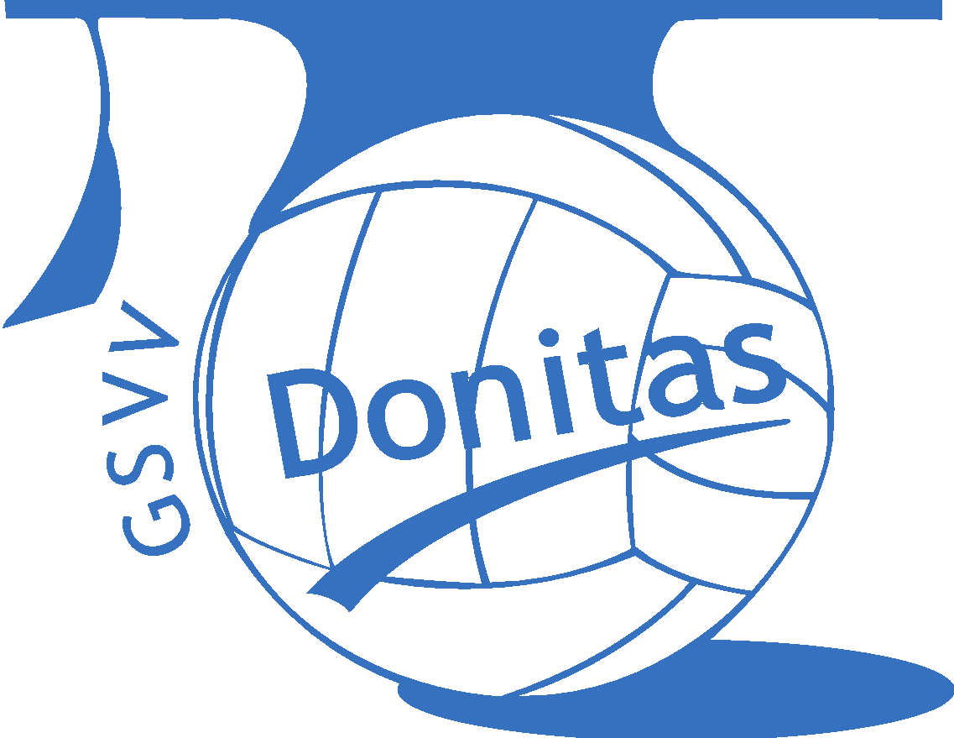 | Incassant: G.S.V.V. Donitas  Adres: Blauwborgje 16, 9747 AC Groningen, Nederland  IBAN en BIC: NL64 ABNA 0492 6066 33, ABNANL2A  Incassant-ID: NL86ZZZ400234300000
 | By signing this form you consent to: G.S.V.V. Donitas to continuously send direct debit instructions to your bank to debit an amount from your account and your bank to continuously debit your account in accordance with the instructions of G.S.V.V. Donitas. If you do not agree with this debit, you can have it reversed. Please contact your bank within eight weeks of the debit. Ask your bank for the conditions.
First and surname: …………………………………………………………
City: …………………………………………………………
ZIP code and address: …………………………………………………………
Country: …………………………………………………………
IBAN Bank account number: …………………………………………………………

Place and date:

Signature: Comments:

